Personal Finance Expenses Analysis Project

Prepared by: Syed Karimoon
Tools: Excel, MySQL, Power BI

1. Project Overview
This project analyzes personal finance expenses to understand spending behavior, identify recurring costs, track high‑value transactions, and support better financial decisions. The project is built end‑to‑end using Excel, MySQL, and Power BI, following a realistic data‑analytics workflow.
Key Objectives - Track income and expenses month‑wise - Analyze expenses by category and sub‑category - Identify recurring and high‑value transactions - Build interactive dashboards for insights

2. Tools Used
- Microsoft Excel – Data entry, cleaning, and initial analysis
- MySQL – Structured storage and querying of financial data
- Power BI – Data modeling, visualization, and dashboard creation

3. Excel – Data Preparation & Initial Analysis

3.1 Purpose of Excel
Excel is used as the starting point for the project where raw expense data is recorded and prepared before loading into MySQL and Power BI.

3.2 Data Structure in Excel
Each row represents one financial transaction.
Main Columns - Date - Month - Category (Food, Rent, Travel, Utilities, etc.) - Sub‑Category (Groceries, Electricity, Fuel, etc.) - Description - Amount - Payment Mode (Cash, UPI, Card) - Expense Type (High / Low) - Recurring (Yes / No)
Excel raw data:
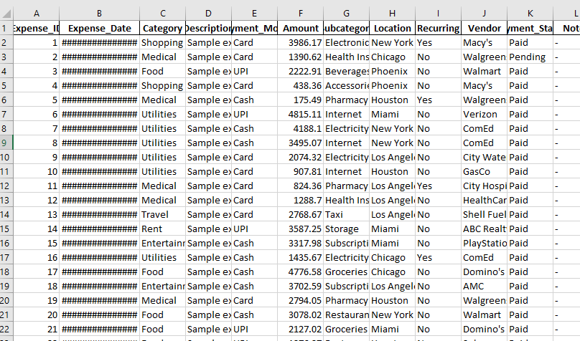

3.3 Excel Activities Performed
- Removed blank rows and duplicates
- Standardized category and sub‑category names
- Converted date column to proper date format
- Added calculated columns:
  - Month
  - Expense Type (High / Low)
  - Recurring Flag
Clean Data:
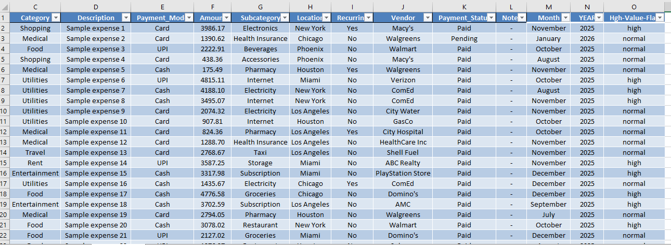

3.4 Excel Analysis
- Monthly expense totals using Pivot Tables
- Category‑wise expense summary
- High‑value transaction identification
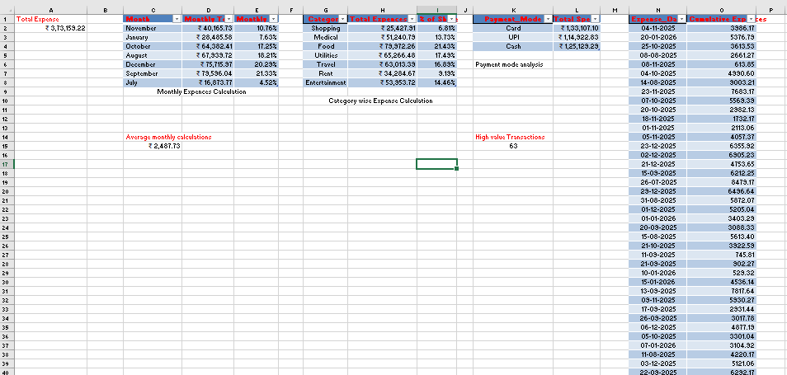
Pivot Tables:
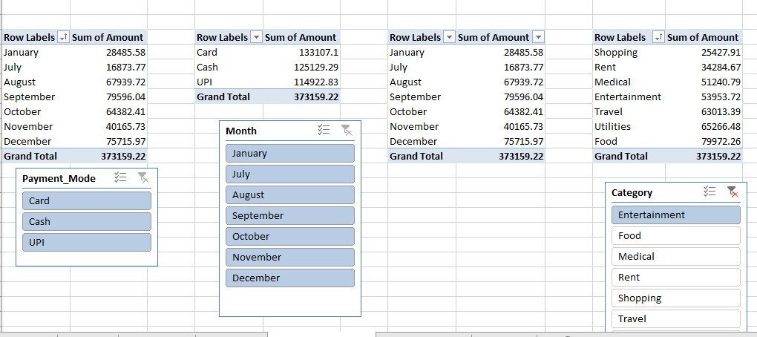

3.5 Output from Excel
- Cleaned and structured dataset
- Ready‑to‑import Excel file for MySQL and Power BI

4. MySQL – Database Design & Querying

4.1 Purpose of MySQL
MySQL is used to store financial data securely and perform analytical queries that simulate real‑world database usage.

MySQL Implementation and Analysis

Goal:
Import your Excel table into MySQL so you can:
- Practice SQL queries
- Use it as a resume project
- Later connect it to Power BI
METHOD USED: Excel → CSV → MySQL

STEP 1: Prepare Your Excel File
- Open Excel file
- Make sure:
  - Row 1 = Column names (headers)
- Click File → Save As
- Choose Save as type:
CSV (Comma delimited) (*.csv)
- Name it:
- sales_data.csv
- Save it (click Yes)

STEP 2: Open MySQL Workbench
- Open MySQL Workbench
- Click on your connection (example: Local instance MySQL)
- Enter root password
- You will see the SQL Editor screen

STEP 3: Import CSV into MySQL
- In MySQL Workbench
- On the left side → Schemas
- Expand excel_sql_project
- Right-click Tables
- Click Table Data Import Wizard

Wizard Steps:

Step 1:
- Select file:
sales_data.csv
- Click Next
Step 2:
- File type: CSV
- Encoding: utf-8
- Check "First row contains column names"
- Click Next

Step 3:
- Choose Existing Table
- Select: sales_data
- Click Next

Step 4:
- Review mapping
- Click Next
Step 5:
- Click Import
You will see Import completed successfully

4.2 Database Design
Database Name: finance_expenses_db
Main Table: expenses
Table Columns - expense_id (Primary Key) - expense_date - month - category - sub_category - description - amount - payment_mode - expense_type – recurring
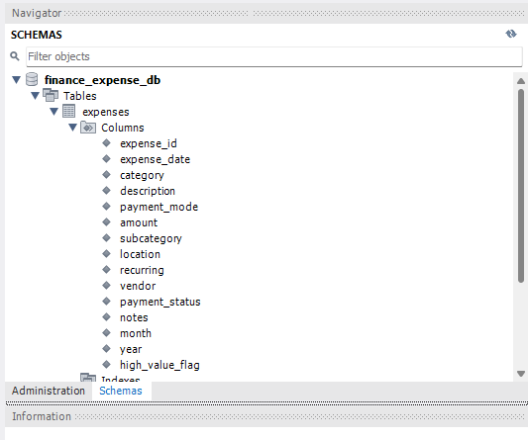

4.3 Why Normalization Was Limited
The project uses a single fact table because: - Dataset size is small - Categories are stable - Goal is analytics, not transaction processing

4.4 Sample Queries Used
- Total expenses by month
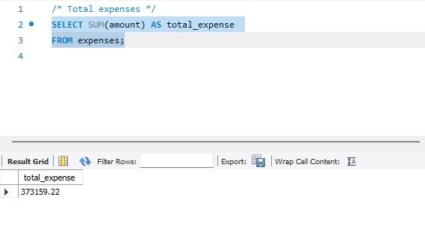
- Category‑wise expense sum
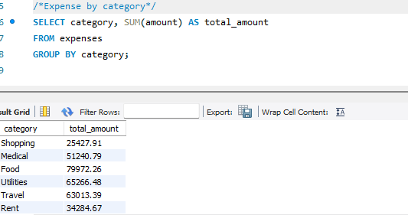
- High‑value transactions coun
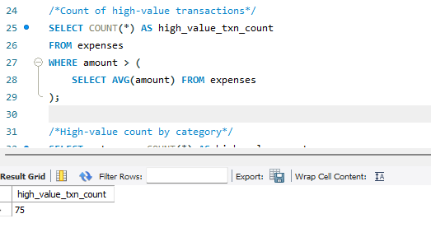
- Month Wise Total Expenses
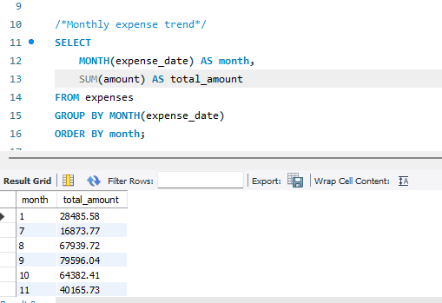

- Top Spending Categories:
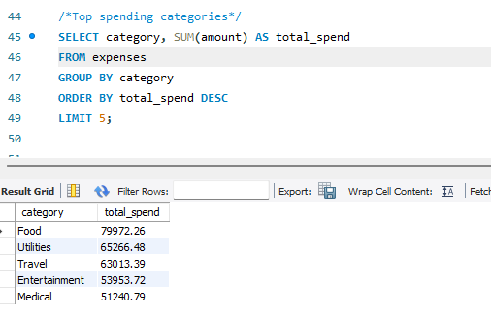

4.5 MySQL–Power BI Integration
- Created a dedicated MySQL user for Power BI
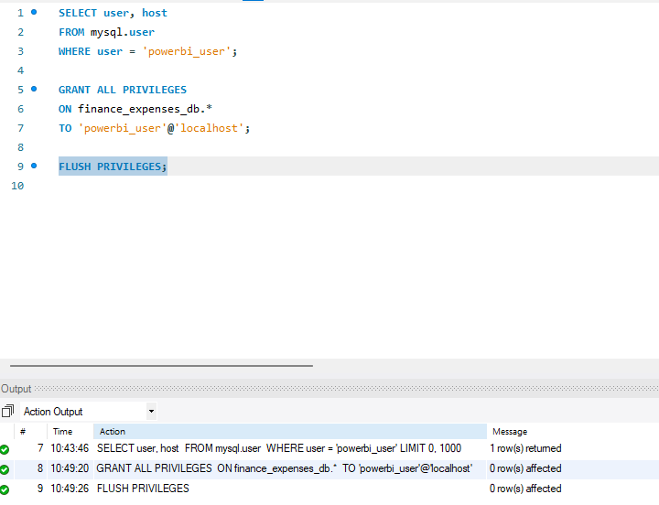

- Granted database‑specific privileges
- Connected Power BI using MySQL connector

5. Power BI – Data Modeling & Visualization

5.1 Purpose of Power BI
Power BI is used to transform data into interactive dashboards that provide business‑style insights.

5.2 Data Import
- Connected Power BI to MySQL database
- Loaded expenses table
- Verified data types and relationships

5.3 Data Modeling
- Date hierarchy for month‑wise analysis
- Category → Sub‑category drill‑down
- Measures created using DAX:
  - Total Expenses
  - Monthly Expenses
  - High‑Value Expense Count
  - Recurring Expense Total
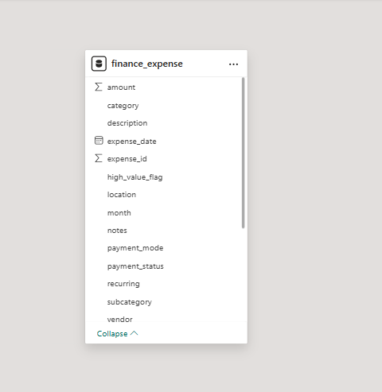

5.4 Visualizations Used
- Card – Total expenses, high‑value count
- Column Chart – Monthly expense trend
- Bar Chart – Category‑wise expenses
- Donut Chart – Payment mode distribution
- Table – Detailed transaction view
- Slicers – Date, category, recurring expenses
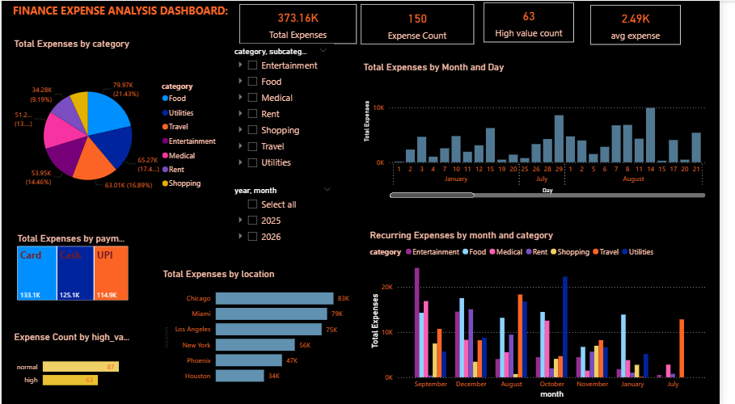

5.5 Dashboard Insights
- Identified months with highest spending
- Found top expense categories
- Detected recurring expenses affecting savings
- Compared high vs low value expenses

6. Project Workflow Summary
- Expense data entered and cleaned in Excel
- Data imported into MySQL database
- SQL queries used for validation and analysis
- Power BI connected to MySQL
- Interactive dashboard created
- Dashboard published to Power BI Service

7. Real‑World Use Case
This project can be used by: - Individuals to track personal spending - Families to manage household budgets - Entry‑level data analyst portfolios

8. Key Learnings
- End‑to‑end data analytics workflow
- Practical use of Excel, MySQL, and Power BI together
- Data cleaning and transformation techniques
- Creating insights using dashboards

9. Conclusion
The Personal Finance Expenses Analysis project demonstrates strong foundational skills in data analysis, database handling, and visualization. It reflects real‑world analytical thinking and is suitable for showcasing in interviews and professional portfolios.

